Curtis Mayberry

**Wireless Connectivity module**

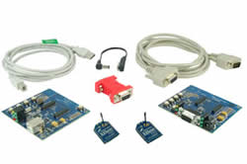

We will be using the Digi (brand) Zigbee PRO (series) XBee and Xbee-PRO (product)  for the wireless communication system.

- Simple 3.3v UART interface that should work with most microcontrollers

- reasonable cost ($17 < cost < $20 per module)

- 40 m to 90 m range (depending on specific model-can use multiple models depending on which room we are in)

-Extendable range, can purchase longer range units that will cost a bit more (still reasonable) and seamlessly interface with the lower range units

- Low power (<40 mA @ 3v for shorter range unit) with adjustable power so the unit may be put in low power mode

-Development kit available ($180) –includes 2 development boards (1 usb, 1 serial) – 2 XBee-Pro modules, other accessories

                -can be used to test ranges and to test bread board prototype

All the manuals are available on Digi’s website.  If you have any other questions or concerns about the wireless module I can find out more, but so far it looks like this will suit our needs perfectly well.

<http://www.digi.com/products/wireless/zigbee-mesh/xbee-zb-module.jsp#specs>